Assignment 4 – Server Admin and Networking

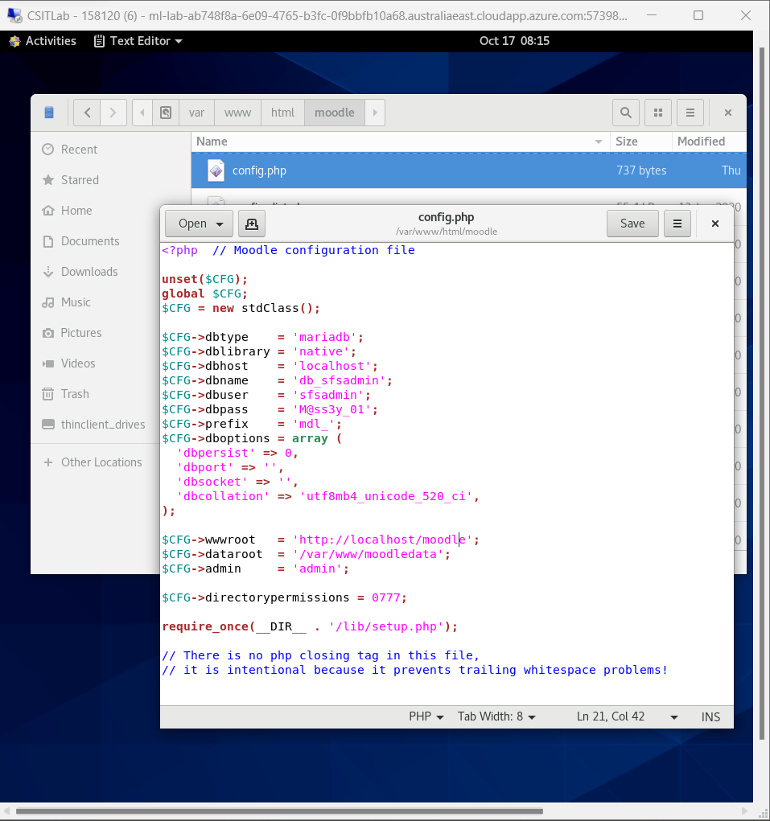**Task 1- Setting up Moodle on new VM**

**Task 2- Working with the VM – Webserver**

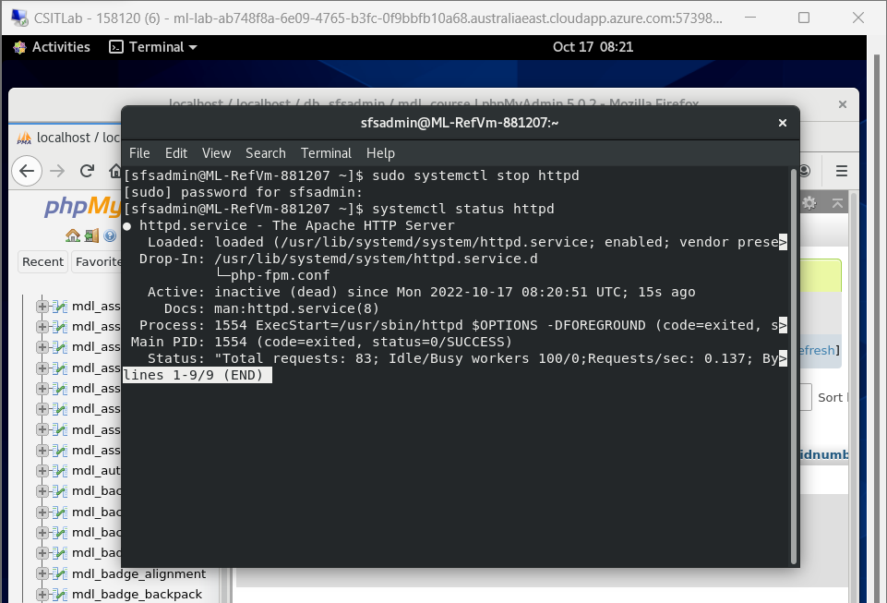

**Task 3- Working with the VM – DBMS**

a)

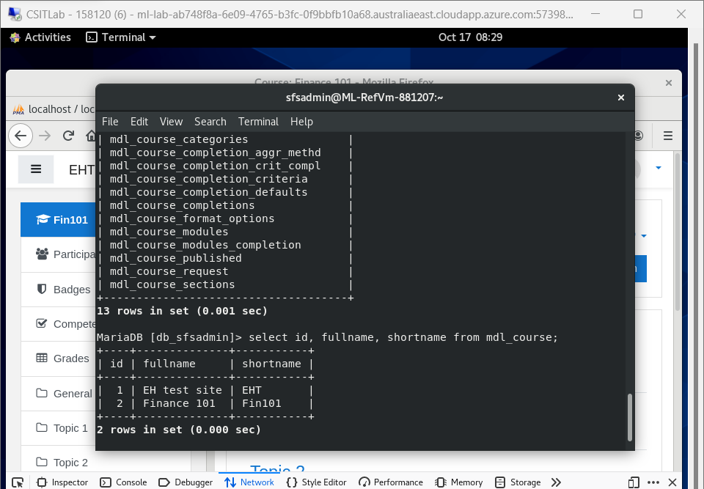

b)

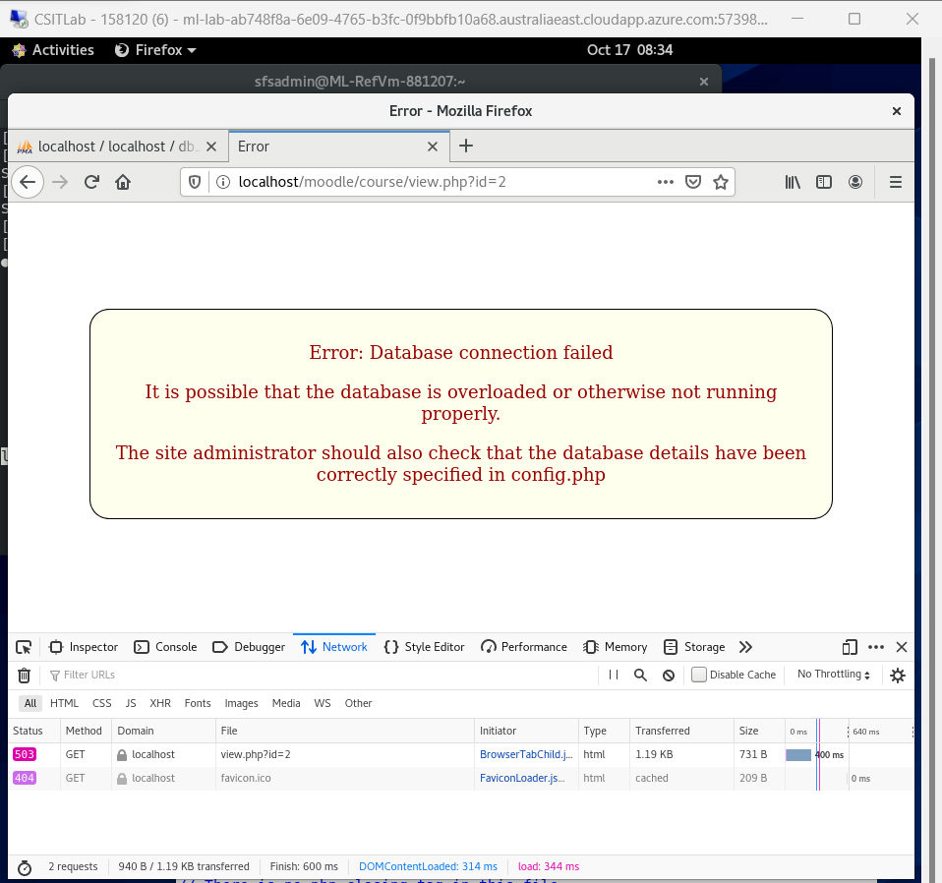

**Task 4- HTTP details**

a)

b)

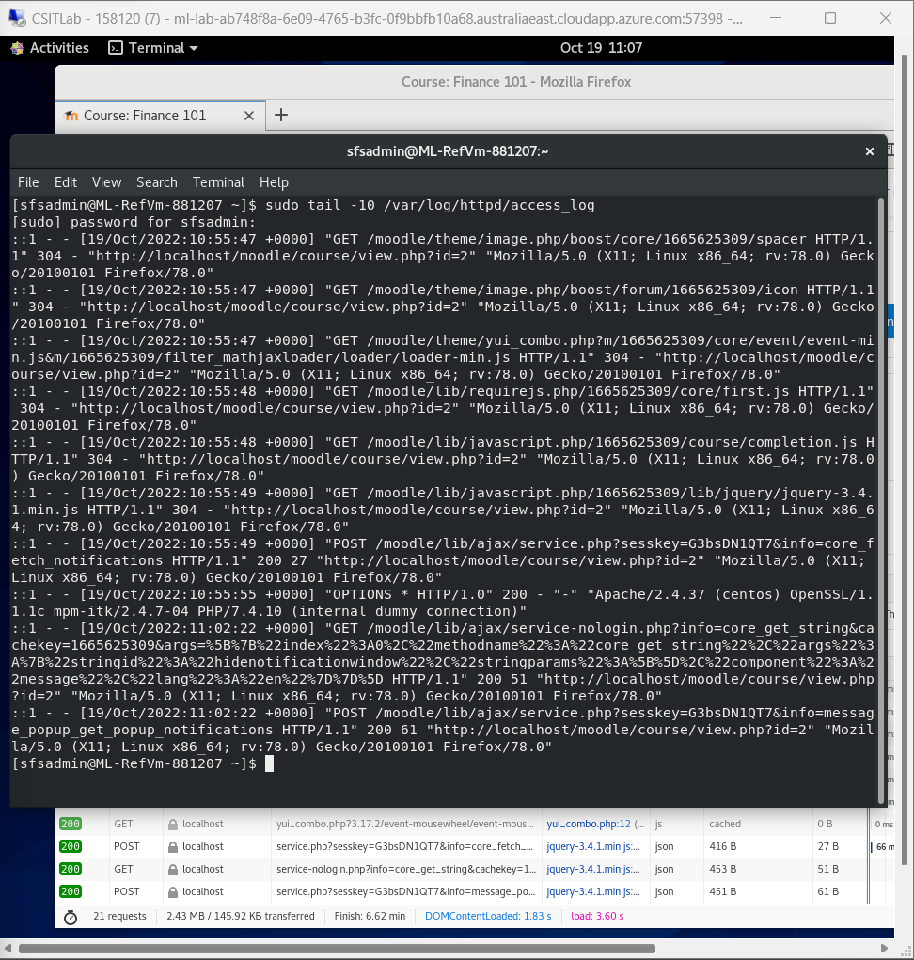

**c)**

Status code 200 means ***successful***, indicates a successful request.

Status code 304 means ***not modified***, the webpage hasn’t been cached.

**Task 5- TCP details**

a)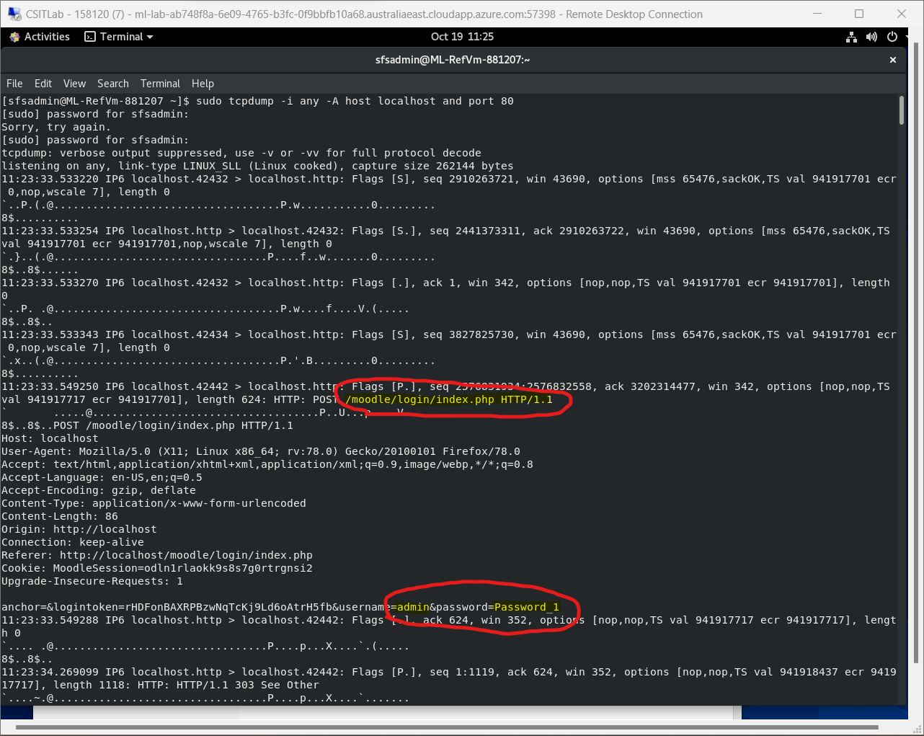

b) a POST requests are associated with logging in because unlike a GET request, post cannot be cached, POST also don’t remain in browser history.